|  |
| --- |
| **Task Eleven** |
| **Vikas S Menon** |

**Objective**: Create a free VM in the cloud and interact with it.

1. Research and learn how to start a *free* VM in your cloud account (Azure is preferred but you can also use GCP/AWS)

**Step 1: Research and Start a Free VM in Azure**

* Go to Azure Portal.
* Sign in with your Azure account (ensure you have a free-tier subscription).

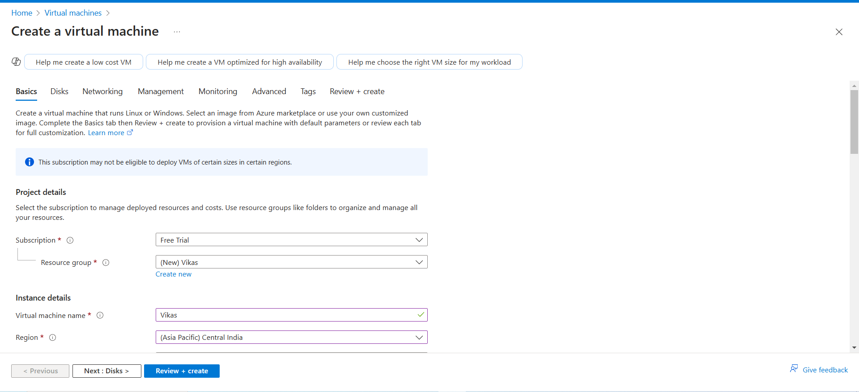

* Navigate to **Virtual Machines** from the Azure dashboard.
* Click **Create** > **Azure Virtual Machine**.

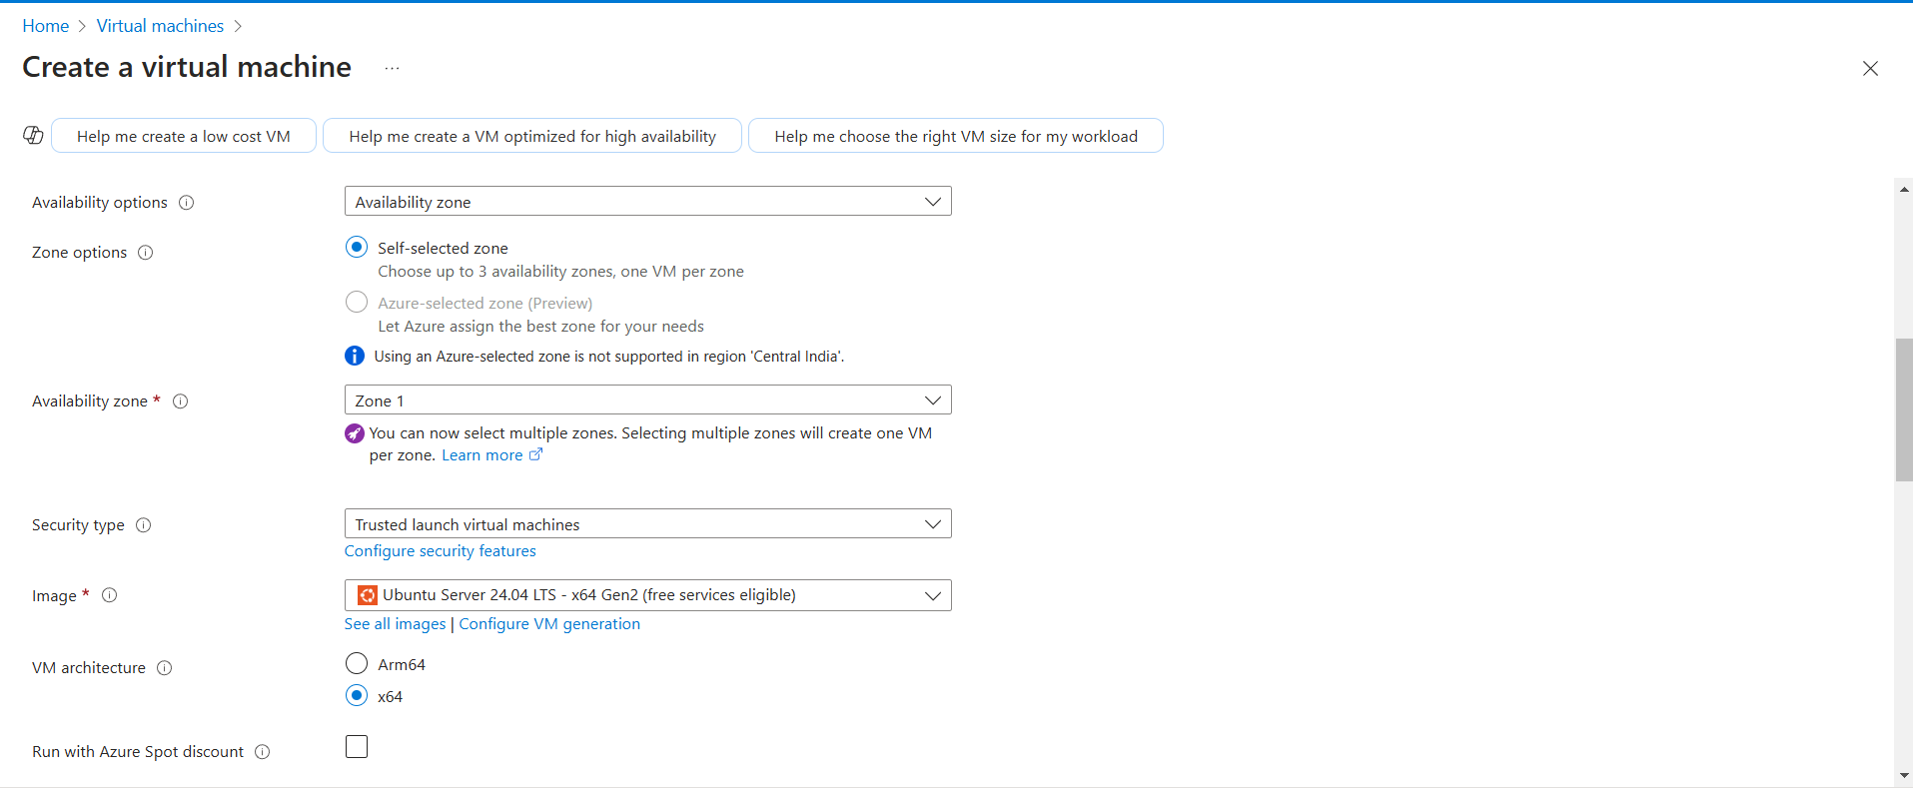

* Select an available free-tier VM, such as **Ubuntu Server 24.04 LTS Gen2**
* Choose a **resource group** (or create a new one).

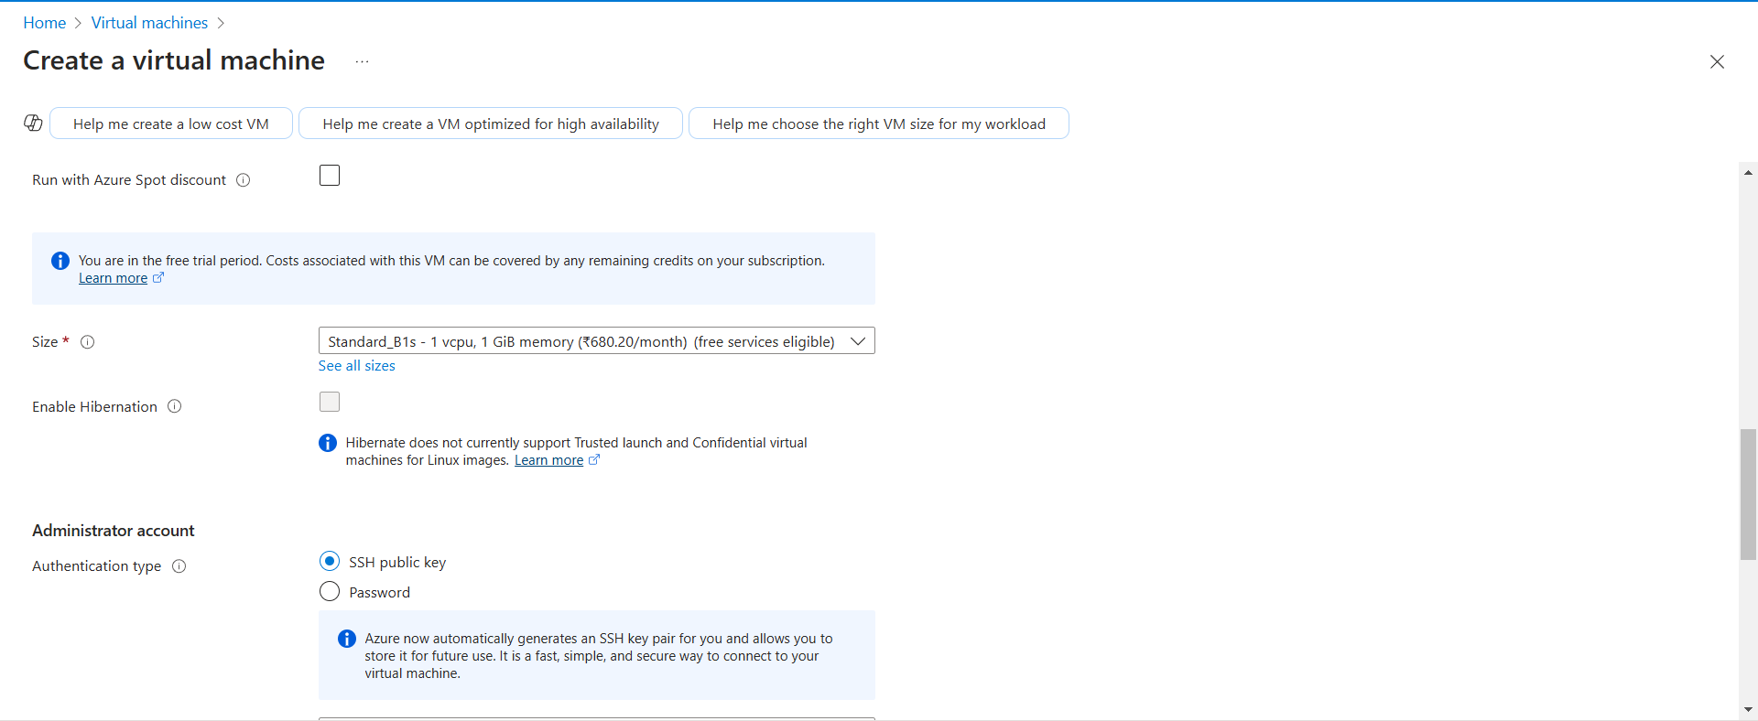

* Set authentication type to **SSH public key** (recommended) or **password**.

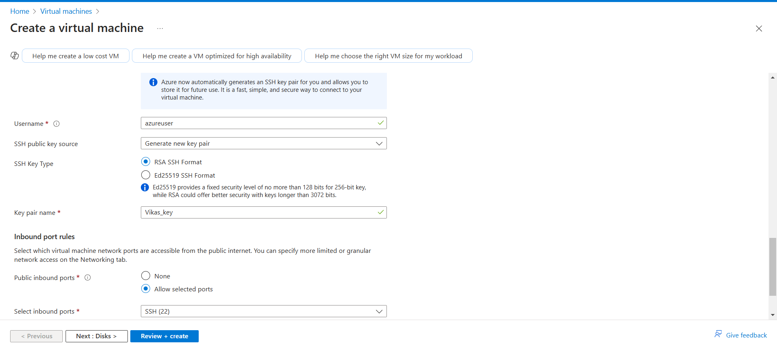

* Ensure **Allow SSH (port 22)** is enabled under **Networking**.
* Click **Review + Create** and then **Create**.
* Wait for the VM to be deployed and note its **public IP** from the Azure dashboard.

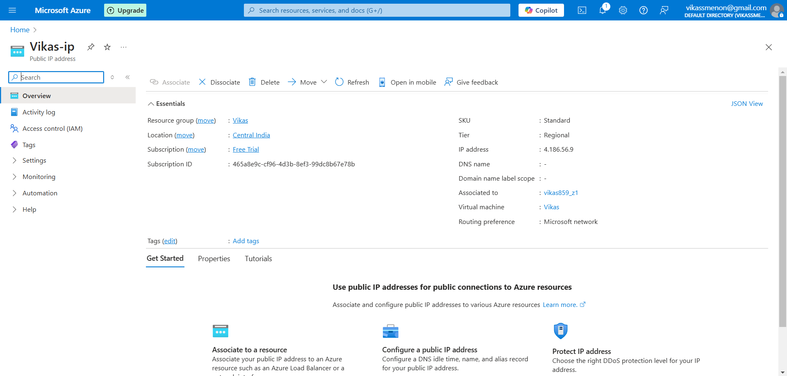

**Step 2: Ping the VM from Kali Linux**

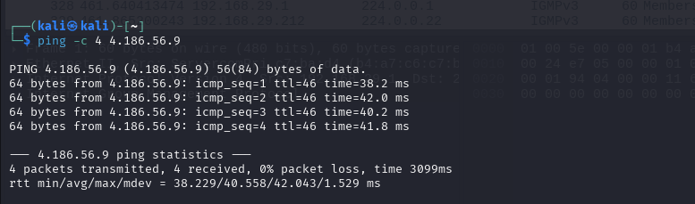

* Open Kali Linux terminal.
* Run the command:

**ping -c 4 <4.186.56.9>**

* If the ping fails, check Azure’s **Networking > Inbound Rules**:
  1. Ensure an inbound rule exists for ICMP (ping) requests.
  2. If not, create a new rule allowing ICMP from **anywhere**.

**Step 3: Login to the VM via SSH**

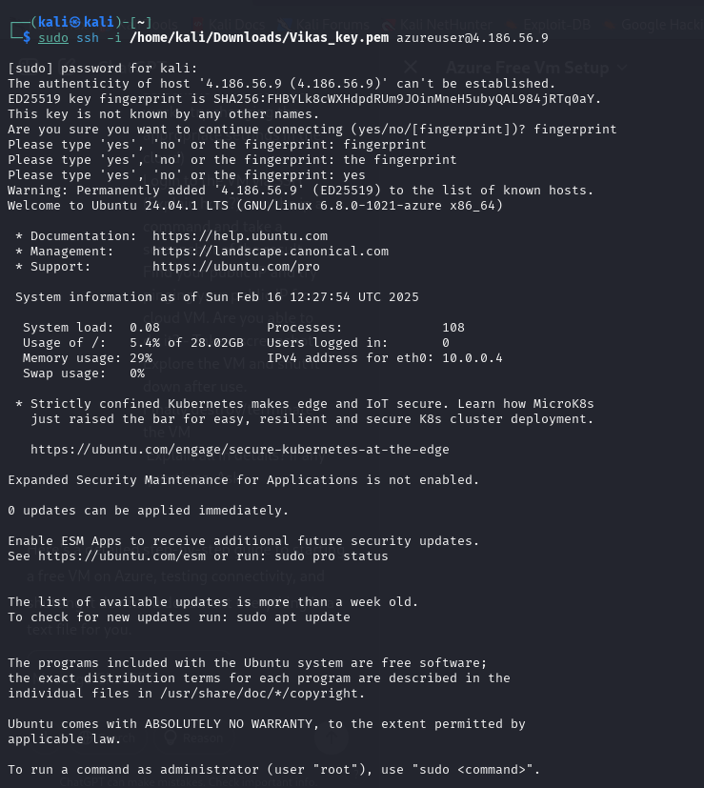

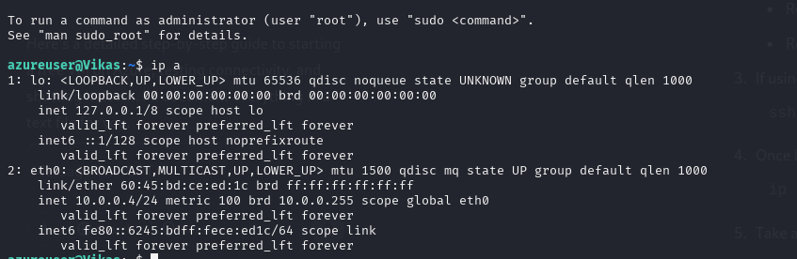

* If you chose **SSH key-based authentication**, ensure your private key is available.
* Connect using:

**ssh -i /home/kali/Downloads/Vikas_key.pem azureuser@4.186.56.9**

* + Replace /path/to/private_key with the actual location of your private key.
  + Replace username with the default username (e.g., azureuser).
* Once logged in, run: **ip a**



**Step 4 :** Find your public IP and try pinging your public IP from cloud VM. Are you able to do it?

1. Find your own public IP:

curl ifconfig.me

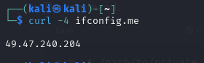

1. Note down the IP and try pinging it from the Azure VM:

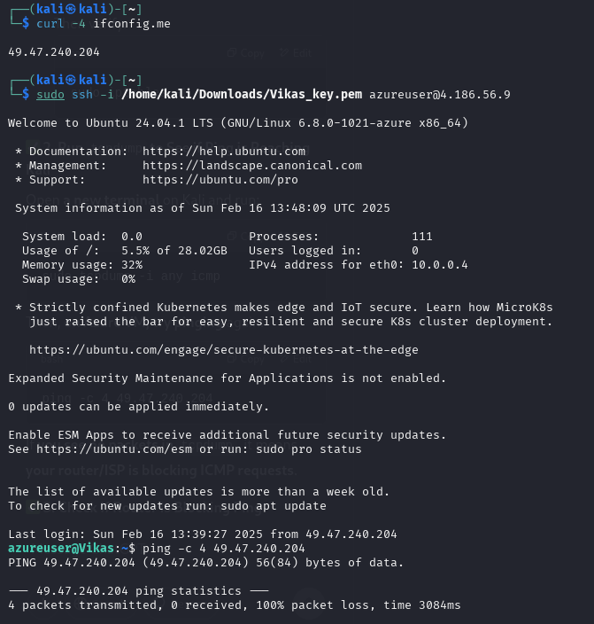

**ping -c 4 49.47.240.204**

**Note:** While try pinging the public IP from cloud VM, no packets are transmitted. It might be because of ISP restriction as there is no internal fire wall blockage.

**Step 5: Shut It Down the VM**

* Shut down the VM safely:

**sudo shutdown -h now**

**Step 6: Destroy/Terminate the VM**

1. Go to **Azure Portal** > **Virtual Machines**.
2. Select your VM and click **Delete**.
3. Delete the associated **resource group** to remove all dependencies.
4. Confirm deletion and ensure all resources are removed.